ITHEA Sample Sheet for Preparing papers

Krassimir Markov

**Abstract**: The rules for preparing the manuscripts for the ITHEA International Journals (IJ), International Conferences, and International Book Series (IBS) are given. The form for the papers is shown by this sheet.

**Keywords**: ITHEA formatting rules.

**ITHEA Keywords**: Please use keywords from <http://idr.ithea.org/tiki-browse_categories.php> .

**Conference and topic**: Please point here the ITHEA International Conference and its topic. ITHEA International Conferences and theirs topics are available in the Call for Papers and the corresponded conference web-pages at the link: <http://www.ithea.org/conferences/conferences.html>.

**DOI**: <https://doi.org/10.54521/IJnameVolumeIssuePaper>

Introduction

We ask authors to follow some simple guidelines.

*In essence, we ask authors to make papers look exactly like this document.*

This text is a sample for preparing the manuscripts for publishing in ITHEA International Journals, Conferences, and Book Series. All styles needed for formatting the papers are included.

The easiest way to prepare your manuscript in accordance of these rules is simply to replace the content of this sample sheet with your own material.

Responsibility for papers published in ITHEA International Journals and Book Series belongs to authors.

Please *get permission to reprint* any copyrighted material.

The camera-ready copy of the paper should be received by the ITHEA Journal Submission System ( *<http://ij.ithea.org>* ) or respectively by the ITHEA Conference Submission System ( [*http://ita.ithea.org*](http://ita.ithea.org) );   
e-mail for questions: [*info@foibg.com*](mailto:info@foibg.com).

Instructions for Preparation of Manuscripts

The authors are hoped to prepare manuscripts in close accordance with the instructions given below.

This text is a sample for preparing the articles. All styles needed for formatting the papers are included. Do not include any new styles. Please, *do not use automatic numbering anyway*, because of losing the information during the assembling the journals or books.

**Name the file** of the manuscript beginning with the journal or conference name, following with the family names of the authors or if they are more than 2 authors – name of the first author, followed by "_et_al".

For instance if the manuscript will be submitted to:

* IJ ITK 2022 from Jackson and Williams, than the file needs to be named:  
  "**IJITK22-Jackson_Williams.docx**";
* IJ ITA 2022 from Jackson, Williams, and Davis, than the file needs to be named:   
  "**IJITA22-Jackson_et_al.docx**";
* i.TECH 2022 from Jackson and Williams, than the file needs to be named:   
  "**iTECH22-Jackson_Williams.docx**";
* i.TECH 2022 from Jackson, Williams, and Davis, than the file needs to be named:   
  " **iTECH22-Jackson_et_al.docx**".

Manuscripts will be peer reviewed and evaluated for originality, significance, clarity, and soundness according to criteria of peer review procedure.

The authors of the accepted manuscripts will be allowed to make a correction in accordance with the suggestions of the reviewers and to submit final camera-ready manuscripts within the stipulated deadline.

ITHEA Manuscript Preparing Styles (ITHEA MPS) are obligatory for manuscripts submitted to ITHEA.

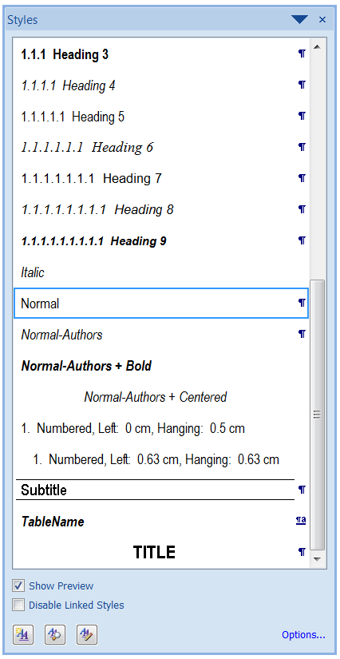

Figure 1. Part of the list of the ITHEA MPS

In order to see ITHEA MPS please press ALT+CTRL+SHIFT+S in this ITHEA template document. You will see the window shown on Figure 1. To apply style to some part of text, please press on name of the style.

How to apply ITHEA MPS styles to your document:

* Open the file you would like to format and click *Office Button→Word Options*  
  (Word 2007) /*File→Options* (Word 2010).
* Choose *Add-Ins* on the left side, and then select *Templates* in the drop-down list at the bottom of the dialog. Click *Attach* in the dialog box that opens, navigate to your working directory, select the ***ITHEA.dotm*** template,
* Click *Open*. Check the option *Automatically update document styles* and click *OK*.

Main ITHEA formats for manuscripts

Format of the pages is **A4** paper (210 x 297mm).

**Margins** of the paper sheet are: top - 30mm; bottom, left, right - 25mm.

**Plain text** has to be formatted by ITHEA MPS ***“Normal”*** style.

"**Normal**" style features: Arial; 12pt; 1.4-spaced text; 3pt before and after each paragraph; without special indents; left and right justification.

Use the ITHEA MPS style *"****Subtitle****"* for the titles of the separated parts of the article.

**Figures and tables** should be positioned in the body of the text, as close as possible to the relevant text.

Caption of the table should be formatted by ITHEA MPS style ***“Table”***.

"**Table**" style features: Arial; 12pt; font size 12-point. Spacing before and after should be of 18-point and 3-point, respectively. Captions should be set to justify.

Tables must appear inside the designated page margins. Tables should be properly numbered, and should always have a caption positioned above it. After table one black space should be left.

Titles of the columns should be centered. Text information should be aligned to left, numbers - to right.

Table 1. Two columns table

|  |  |
| --- | --- |
| Title1 | Title2 |
| text 1 | text 2 |
| number 1 | number 2 |

Please prepare your ***figures*** electronically, and integrate them into your document.

Check that in line drawings, lines are not interrupted and have a constant width. Grids and details within the figures must be clearly readable and may not be written one on top of the other.

Figure resolution should be ***at least 300 dpi.***

Figures should be properly numbered, centered and should always have a caption positioned under it. Captions should be centered. To caption apply ITHEA MPS ***“Normal”*** style with *Italic* font. Before figure one black space should be left. After caption of table also one black space should be left.

***Number*** ***manually*** all figures and tables. Use these numbers to point them in the text. Note that the position of figures and tables may be changed during the assembling the journals or books. Color figures are good for electronic variant but they will be printed in grayscale and some colors may look as equal.

The size of picture should not exceed sixteen centimeters width (15 cm.) and twenty centimeters high (20 cm.). Check it doing the next: wright mouse button click on picture -> “Picture format”->Size. The picture below (Figure 2) is formatted to maximum width - 15 cm.

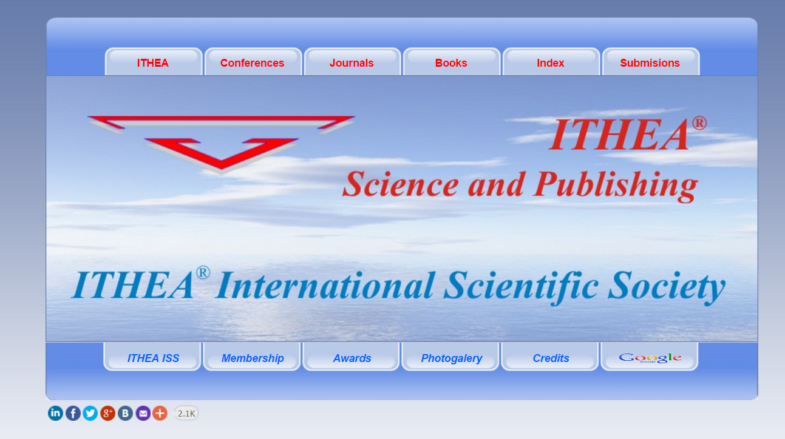

Figure 2. Example of figures placing, signing, and formatting

**Program Code:** Program listing or program commands in text should be set in ITHEA MPS ***“Code”***. Example of a Computer Program in C#: Before and after code section left black lines. "**Code**" style features: Arial; 12pt. Code lines should be justified to left.

string s = "456-435-2318";

Regex regex = new Regex(@"\d{3}-\d{3}-\d{4 }");

**Lists** are formulated by ITHEA MPS style “***List***”. To mark list points you may use numbers or dashes (-)

"**List**" style features: Arial; 12pt; Spacing between marker (number or dash) and text is 1.4.

Example one:

* One;
* Two;
* Three
* …
* One hundred.

All strings, except the last one, in “example one” should start with capital letter and finished by “;”.

Example two:

1. One;
2. Two;
3. Three;
4. …
5. One hundred.

All strings, except the last one, in “example two” should start with capital letter and finished by “;”

Try to avoid nested lists, contained more than three levels of nesting.

**Formulas** should be positioned in the body of the text, as close as possible to the relevant text.

Put formula and its number in a table row without borders. Align the formula to the center and its number to the right as follow:

|  |  |
| --- | --- |
|  | (1) |

The MathType INI v1: Equation Preferences are:

**[Styles]**

|  |  |
| --- | --- |
| Text=Arial  Function=Arial  Variable=Arial,I  LCGreek=Symbol,I  UCGreek=Symbol  Symbol=Symbol | Vector=Times New Roman,B  Number=Times New Roman  User1=Arial  User2=Arial  MTExtra=MT Extra |

**[Sizes]**

|  |  |
| --- | --- |
| Full=11 pt  Script=58 %  ScriptScript=42 %  Symbol=150 % | SubSymbol=100 %  User1=75 %  User2=150 %  SmallLargeIncr=1 pt |

**[Spacing]**

|  |  |  |
| --- | --- | --- |
| LineSpacing=150 %  MatrixRowSpacing=150 %  MatrixColSpacing=100 %  SuperscriptHeight=45 %  SubscriptDepth=25 %  SubSupGap=8 %  LimHeight=25 %  LimDepth=100 %  LimLineSpacing=100 %  NumerHeight=35 % | DenomDepth=100 %  FractBarOver=8 %  FractBarThick=5 %  SubFractBarThick=2.5 %  FractGap=8 %  FenceOver=8 %  OperSpacing=100 %  NonOperSpacing=100 %  CharWidth=0 %  MinGap=8 % | VertRadGap=17 %  HorizRadGap=8 %  RadWidth=100 %  EmbellGap=12.5 %  PrimeHeight=45 %  BoxStrokeThick=5 %  StikeThruThick=5 %  MatrixLineThick=5 %  RadStrokeThick=5 %  HorizFenceGap=10 % |

**References** in the text should be keyed with the name(s) and year of the referred material - for instance [Shannon, 1949].

Put list of **bibliography** after the text of the article using the ITHEA MPS style "**Bibliography**".

**Code**" style features: Arial; 12pt, Italic; justified to left; hanging 0.5 cm.

**Author's Information:** Finish the article with the personal information for every author separately: photo, name of the author, position, organization(s), post and e-mail address(es), major fields of scientific research (keywords). For this information use style "**Normal-Authors**".

Note that the only way to contact the authors is pointed e-mail address in the author's information. Be sure that the addresses are written correctly. If you (or your internet provider) use anti-spam protector write the way to access the e‑mail address.

**For papers written in Russian,** the title, authors, abstract, and keywords in English are obligated. Insert them at the end of paper after authors’ information.

Recommended structure of the manuscripts to be published by ITHEA

The papers should contain: Title; Authors; Abstract, Author’s keywords and ITHEA keywords; Introduction (objective, used methodology and terminology); Short survey of related papers; Task and challenges; Proposed approach; Case study or implementation of results; Conclusion; Further researches; Acknowledgements; Bibliography; Appendices; Author’s information, Annex for. papers written in Russian (for papers written in Russian the title, authors, abstract, and keywords in English are obligated. Insert them at the end of paper after authors’ information).

Some comments to the parts of the manuscripts are given below:

* **Title:** Title of the paper should be formatted by the style "**Title**" of ITHEA MPS.
* **Authors:** The name(s) of the author(s),are formatted by the style **"Authors"** of ITHEA MPS. Please, write the whole ***first name and surname*** of the authors.
* **Abstract:** The abstract of the paper is formatted by the style "**Abstract**" of ITHEA MPS. The abstract needs to be from 100 to 350 words long. Note that the abstract is very important for directing the paper to the right reviewers. State the problem, your approach and solution, and the main contributions of the paper. Include little if any background and motivation. Be factual but comprehensive. The material in the abstract should not be repeated later word for word in the paper.
* **Keywords:** Keywords are applied by ITHEA MPS style **“Keyword”** respectively. Papers should contain up to 5 keywords. Keywords are authors designated keywords.

Also please see ITHEA conference topics given in the Call for papers available at the ITHEA International Conferences page: <http://www.ithea.org/conferences/conferences.html>, as well as ITHEA journal topics and sub-topics given at the ITHEA International Journals pages:

* “Information models and analyses”: <http://www.foibg.com/ijima/ijima-finfo.htm> ;
* “Information theories and applications”: <http://www.foibg.com/ijita/ijita-finfo.htm> ;
* “Information technologies and knowledge”: <http://www.foibg.com/ijitk/ijitk-finfo.htm> ;
* “Information content and processing”: <http://www.foibg.com/ijicp/ijicp-finfo.htm> .
* **ITHEA keywords:** Please use keywords from ITHEA Classification Structure (Figure 3), given at: <http://idr.ithea.org/tiki-browse_categories.php> .

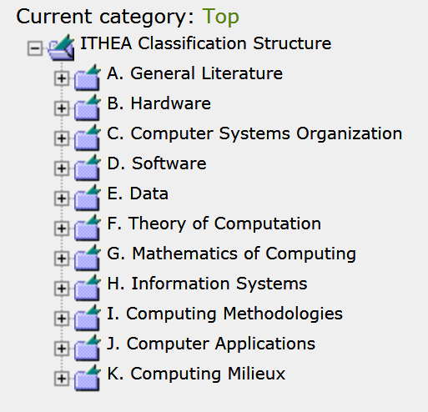

Figure 3. ITHEA Classification Structure (based on ACM Classification System)

* **Introduction:** It is advisable to represent description of research objective, used methodology and terminology. The Introduction is crucially important. Here is the Stanford InfoLab's patented five point structure for Introductions [Widom, 2006]. Unless there's a good argument against it, the Introduction should consist of five paragraphs answering the following five questions:  
  1. What is the problem? 2. Why is it interesting and important? 3. Why is it hard? (E.g., why do naive approaches fail?) 4. Why hasn't it been solved before? (Or, what's wrong with previous proposed solutions? How does mine differ?) 5. What are the key components of my approach and results? Also include any specific limitations.

Then have a final paragraph or subsection: "Summary of Contributions". It should list the major contributions in bullet form, mentioning in which sections they can be found. This material doubles as an outline of the rest of the paper, saving space and eliminating redundancy.

* **Related work:** Authors are advised to provide wide review, reflecting state of art for latest achievements in investigated area. Describe solutions close to paper topics, represented in leading periodical issues (it may be journals, proceedings, books, etc.). Also it is advisable to explain the place of task, investigated in current paper, in common authors’ researches. You may reference to your previous papers to distinguish unanswered questions or aspects needed to be improved.
* **Task and challenges:** Formulate task clearly and laconically. Challenges are ground why the results of your investigation should look like as you formulate in task.
* **The Body:** It is aimed to present the main results, proposed approach, etc. The structure of the body varies a lot depending on content but important components are [Widom, 2006]: (1) *Running Example*: When possible, use a running example throughout the paper. It can be introduced either as a subsection at the end of the Introduction, or its own Section 2 or 3 (depending on Related Work). (2) *Preliminaries*: This section, which follows the Introduction and possibly Related Work and/or Running Example, sets up notation and terminology that is not part of the technical contribution. One important function of this section is to delineate material that's not original but is needed for the paper. (3) *Content*: The meat of the paper includes algorithms, system descriptions, new language constructs, analyses, etc. Whenever possible use a "top down" description: readers should be able to see where the material is going, and they should be able to skip ahead and still get the idea.
* **Case study or implementation of results:** In this section an evaluation of the presented results has to be done. Usually, it is a practical implementation and/or a theoretical analysis. A comparison with leading results in the same scientific area is very important to be given.
* **Conclusion:** Obtained results and comparing them with similar results in the world, and references. In general a short summarizing paragraph will do, and under no circumstances should the paragraph simply repeat material from the Abstract or Introduction. In some cases it's possible to now make the original claims more concrete, e.g., by referring to quantitative performance results [Widom, 2006].
* **Further work:** Interconnect results presented in the paper with general task of your research. This material is important part of the value of a paper is showing how the work sets new research directions.
* **Acknowledgements:** This is the right place to point the Project or any other source for partial support of your publication. Also, acknowledge anyone who contributed in any way: through discussions, feedback on drafts, implementation, etc. If in doubt about whether to include someone, include them. If your paper is supported by ITHEA ISS to be published with reduced fee, please include the obligatory acknowledgement: *"The paper is published with partial support by the ITHEA ISS (www.ithea.org) and the ADUIS (*[*www.aduis.com.ua*](http://www.aduis.com.ua)*)"*
* **Bibliography:** Please use the following template for references formatting:

[Family name of the first author, publication year] First author family name, name, Second author family name, name,...,N-th author family name, name. Title of the publication. Name of the journal, proceedings, book. Volume, Issue, Publisher, year, pages, link to resource (if exists).

***Examples*** for referring book, journal, and conference proceeding:

***Reference to book:***

[Shannon, 1949] C.E. Shannon. The Mathematical theory of communication. In: The Mathematical Theory of Communication. Ed. C.E.Shannon and W.Weaver. University of Illinois Press, Urbana, 1949.

***Reference to journal:***

[Smith and Brown, 2003] Smith, V., Brown, A., To be or not to be. Journal ABCDEF, Vol.2, Issue 3. Springer-Verlag, 2003. pp. 187-210. ISSN: 0123-0123 (print version), ISSN: 1619-1374 (on-line), doi:00099994342342 <http://article-link.com>

***Reference to proceedings:***

[Jackson et al, 2016] Jackson J., Williams D., Davis Y., Software engineering In: i.Tech 2016, Proceedings of the 19th International Conference information technologies. Edited by A. Test, B. Test. ITHEA Sofia, Bulgaria, 2016. ISBN: 123 456 789 012-X, pp. 87-98. DOI xxxx-yyyyyyy, http://proceeding-link.com

* **Appendices:** Appendices should contain detailed proofs and algorithms only. Appendices should not contain any material necessary for understanding the contributions of the paper as well as all material that most readers would not be interested in.
* **Author’s information:** This information is very important for contact with all authors to be contacted during the publishing process. Do not forget to check if the e-mail addresses are correct. Photo and Major Fields of Scientific Research are important, too. This information is useful for readers for further collaboration with authors especially during the conferences time.

Conclusion

This exemplar is meant to be a model for manuscript format. Please make your manuscript look as much like this exemplar as possible. In case of serious deviations from the format, the paper will be returned for reformatting.

Bibliography

[Widom, 2006] Widom Jennifer. Tips for Writing Technical Papers. Stanford InfoLab, 2006. <https://cs.stanford.edu/people/widom/paper-writing.html>

Authors' Information

|  |  |
| --- | --- |
| photo-Markovw | **Krassimir Markov** – Institute of Information Theories and Applications; ITHEA Editor in chief. P.O. Box: 775, Sofia-1090, Bulgaria; e-mail: [markov@foibg.com](mailto:markov@foibg.com)  Major Fields of Scientific Research: General theoretical information research, Multi-dimensional information systems |

Annex for papers written in Russian

**ITHEA IJ and IBS Sample Sheet for Preparing the Manuscripts**

**Krassimir Markov**

***Abstract****: For papers written in Russian the title, authors, abstract, and keywords in English are obligated. Insert them at the end of paper after authors’ information, i.e. just here.*

***Keywords****: (Keywords are your own designated keywords).*